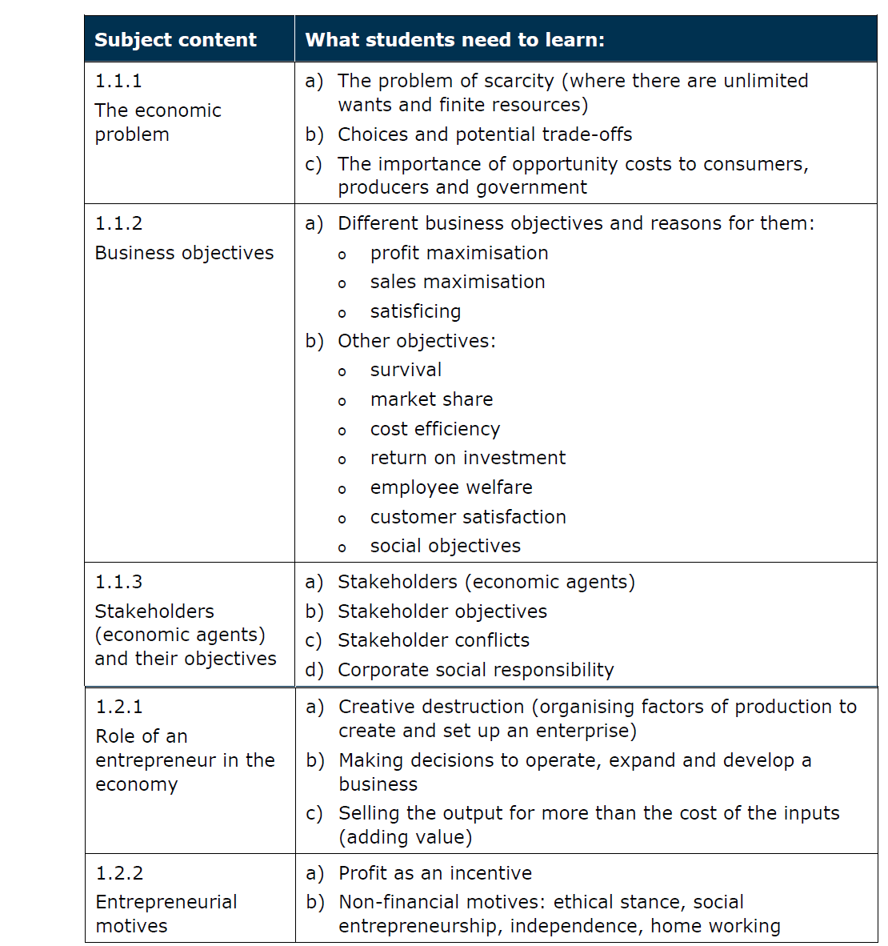***GAP Task: GCE A-level Economics B Theme 1, section 1.1/1.2 – exam style questions***

Case study adapted from May 2014 Unit 1 old spec:

**Marvin – Mr Motivator!**

As a teenager, Marvin Burton battled with his weight. By the time Marvin left school he was 16 stone (100 kgs), so he decided to work in the fitness industry to try and help overcome his weight problem. Marvin worked in a number of roles from gym receptionist, aerobics instructor, personal trainer, to the Director of Fitness on a cruise ship – teaching and training over 2,000 passengers!

As an essential part of his professional development, Marvin studied and often undertook training in areas such as sports massage therapy, diet and nutrition and anatomy.

In 2008, Marvin started his own fitness company, Advanced Conditioning Ltd. Although it was a risk and there was lots of uncertainty at the start, he made a success of it. He often worked with professional sports people on a one-to-one basis. Marvin also ran group exercise classes. Since much of his work required him to be flexible, he set up an office at home. When Marvin needed a fitness studio or large equipment for his clients, he simply hired it, often from well-known health club chains, such as Virgin Active.

In 2011 and after 3 years of careful market research and thinking ‘creative destruction’, Marvin spotted a gap in the market. He teamed up with four other self-employed professional sports trainers, a masseur and a chef, to provide exclusive and relatively expensive well-being stay away breaks aimed at the top end of the market. The team, operating collectively as Fitness Retreat Ltd, hire luxury countryside venues such as The Lindens, in Dorset. The Lindens is a fabulous 18th century manor house which has a heated swimming pool, all-weather tennis courts and acres of amazing woodland and gardens – the perfect setting for a great fitness getaway. The market research that Marvin carried out prior to launch suggested that it was these type of facilities that his target market desired. It was after evaluating his competitors on a market map, that Marvin decide to position himself to the high end of the market.

Fitness Retreat Ltd offers its breaks across the UK for four or seven days. Those who attend learn about exercise, nutrition, motivation, recovery and general well-being. The team use well-proven methods to achieve great results in weight loss and fat burn. There have been many happy clients who achieved their targets. One client, sales manager Lucy Adamson, commented: “I wanted to lose two stone for my wedding. I tried for a long time but found it hard. When I started work with Marvin it seemed as though we didn’t have to do all of the things that I was trying. I looked forward to the sessions and the weight came off easily”

Marvin is first and foremost an international fitness educator, working as a consultant to all major health chains and a number of sports clubs. “I call him the Guru, he’s a legend and makes me laugh. I can’t believe how much he knows” said Matt Richards of Derby County Football Club. When business is quiet – which is rare these days – Marvin writes educational material and trains other trainers.

**Questions: Attempt Questions 1 – 3. The mark scheme is included but only use it to self assess your answers.**

1. **Define creative destruction (2 marks)**
2. **Explain how ‘Fitness Retreat LTD’ adds value to its service (4 marks)**
3. **Discuss whether or not an increase in unemployment might affect Fitness Retreat Ltd (8 marks)**
4. Assess the impact of possible changes in government taxation policy would have on Marvin’s business. (12 marks)

***Mark scheme***

|  |  |  |  |  |  |  |
| --- | --- | --- | --- | --- | --- | --- |
|  | **SECTION** | **AO1** | **AO2** | **AO3** | **AO4** | **TOTAL MARKS** |
| Define/what is meant by | A&B | 2 |  |  |  | 2 |
| Explain | A&B | 1 | 2 | 1 |  | 4 |
| Discuss | A&B | 2 | 2 | 2 | 2 | 8 |
| Assess | A&B | 2 | 2 | 4 | 4 | 12 |

1. Define creative destruction (2 marks) - A full definition that shows knowledge/understanding. E.g. Way in which quality improving innovations lead to economic growth. E.g. customers switch to new products and old products become obsolete (e.g. CDs to MP3s)
2. Explain how ‘Fitness Retreat LTD’ adds value to its service (4 marks) – Analysis of a valid point, in context of the question.

* Define ‘adding value’ (1 mark) – e.g. what the business does with the inputs in order to make the product worth buying.
* State a valid reason how Marvin adds value – e.g. adds branding/luxury to the service in order to provider excellent customer service
* Explain the point fully. E.g. Marvin’s luxurious retreats are therefore charge a high price as the consumer perceives there to be a high degree of value added.

1. Discuss whether or not an increase in unemployment might affect Fitness Retreat Ltd (8 marks) – successful evaluation of any 2 points related.

State any 2 valid agreeing points (2 marks) in the context of the case study (2 marks). Explain these beneficial points fully (2 marks) and then evaluate them with a ‘However…’ point for each (2 marks).

Example agreeing points:

* The unemployed may not be able to take advantage of personal fitness training. This is because disposable incomes of the unemployed tends to fall as people are on benefits rather than wages so could not afford luxury wellbeing stay away breaks.
* Unemployment might affect revenues/profits for the business and result in redundancies and cutbacks. Marvin teams up with sports trainers, a masseur and a chef so he might need to consider down-sizing which would affect the overall quality of end product service if he is missing an aspect.

Example ‘However…’ points:

* Fitness Retreat Ltd targets a niche market with clients who are likely to be well paid and at less risk of losing their jobs which means that sales may not be so affected
* There could actually be a recruitment opportunity, not a threat, in regards to people being willing to work for less during times of high unemployment. Therefore an opportunity for Marvin to expand further and truly dominate his niche market. Sports trainers, masseurs and chefs are highly skilled/paid so it is an opportunity to recruit these on the cheap.

No conclusion/recommendation is required for 8 mark AO4.



1. Assess the impact of possible changes in government taxation policy would have on Marvin’s business. (12 marks)

State any 2 valid agreeing points (2 marks) in the context of the case study (2 marks). Explain this beneficial points to a high level (4 marks) and then evaluate them with a ‘However…’ point for each which is also well developed (4 marks). Give a brief conclusion/recommendation at the end.

Example Agreeing points (any 2 valid points are accepted):

* Income tax increases might reduce the ability of clients to pay for stay away breaks. Because their disposable incomes could be reduced and so spending on non-essential products or services like stay away breaks might fall
* Corporation tax is currently 20% and if it were to change then this would have a drastic affect on Marvin’s retained profit. This would limit his ability to grow internally via reinvesting back into himself, never mind the dividend that gets shared amongst his co-shareholders in the LTD.
* If VAT is increased then this would further elevate Marvin’s prices which might be bad news for he is already perceived as a very expensive service.

Example ‘However…’ points (any 2 valid points are accepted):

* The brand image of Fitness Retreat Ltd might be so strong that clients might continue to pay for stay away breaks, even if income tax is increased
* The reduction in the higher income tax band (arguably Marvin’s target market) in 2013 from 50% to 45% may have actually increased the number of clients for FR because as a result high income people can now afford such luxury breaks because they will be able to keep more of their income
* The corporation tax increase would affect all businesses in the niche, thus not giving any competitor a competitive advantage. If Marvin is good at managing his costs, profit margins can be maintained. Perhaps finding a cheaper but equally luxurious location is an option.
* For Marvin’s affluent target market, a small change in price in VAT would not affect their demand too much (he would be price inelastic).

A conclusion is expected at 12 mark AO4 – a clear and perceptive recommendation should be given.