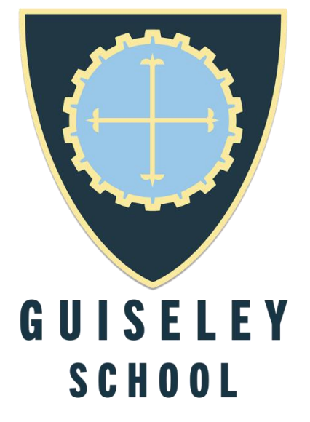

Year 11 Transition Work
AOS1: Baroque Sonata and Concerto

Rationale:
In Year 12, you will study Baroque orchestral music. This is a huge area so you will focus on just 3 set works:

- Purcell- Sonata for Trumpet and Strings
- Vivaldi-Flute Concerto in D major Op 10 no 3 RV428
- J.S. Bach-Violin Concerto no 1 in Am BWV 1041

You will have the scores to these three pieces and through their study you will develop your skills of aural and written analysis.

This series of transition tasks will allow you to get a better understanding of context. Who were these musicians? What else did they write? What did music sound like in this era? Now is the time to listen to as much as you can before you get focussed on these set works. The listening exam will contain an extract from an ‘unfamiliar’ concerto/sonata. You will have to comment on it.

Task 1:

Go to this link: https://www.bbc.co.uk/bitesize/guides/z2mv34j/revision/2

Focus on First 3 pages only!

Familiarise yourself with the orchestra and some key features of the Baroque era. You should make notes on the instrumentation, key stylistic features, the Baroque concerto and orchestral suites. Listen to the Brandenburg no 4. extract.

Task 2:
Write a short summary of the key dates, bibliography and compositions of Henry Purcell. (Between ½-Full page of A4)

Listen to the following pieces:

Dido’s Lament: ‘When I am laid in earth’ from Dido & Aeneas
https://www.youtube.com/watch?v=-H--Z9UzQYE

This is a ground bass (A repeating bass line which the whole piece is created over).

Rondeau from Abdelazer (Z570)
https://www.youtube.com/watch?v=VVivtti-n-w

Note the recurring theme that makes this Rondo form.

Anthem: Rejoice in the Lord Always
https://www.youtube.com/watch?v=kkh6WMcV_ic&t=5s

This is also known as the Bell anthem due to the repeating descending, scalic bass. This is a verse anthem-a religious piece for soloists and ensemble sung in English.

Task 3:
Write a short summary of the key dates, bibliography and compositions of Antonio Vivaldi. (Between ½-Full page of A4)

Listen to the following pieces: https://www.youtube.com/watch?v=nJTfG1MmMwQ

This is the ‘Presto’ from Summer- Vivaldi Four Seasons. This is a solo concerto. Watch the interplay between the soloist and the ensemble.

https://www.youtube.com/watch?v=5v3W3QQY6n4 first 2’25”. (All the movements last 30 mins in total)

This is sung in Latin. The Gloria is a set of words from the Latin mass that have been set throughout history.

Listen to how he sets the words: ‘Gloria in Excelsis Deo’. Sometimes one word -sometimes the whole sentence. Listen to the different textures (In harmony/call and response) used, the key changes and the role of the ensemble.
Task 4:
Write a short summary of the key dates, bibliography and compositions of JS. Bach (Between ½-Full page of A4)

Listen to the following pieces:

https://www.youtube.com/watch?v=rGgG-0lOJjk

A solo cello piece. Melody and harmony all provided by just one instrument.

https://www.youtube.com/watch?v=RNiKx8yHp1w

Brandenburg Concerto no. 2 for 4 soloists and ensemble. A unique combination of solo trumpet, oboe, recorder and violin. This is a concerto Grosso.

https://www.youtube.com/watch?v=kbZ1qJ_kBx8

Originally written for harpsichord. The first Prelude and Fugue in C from a complete set of 24. (One in every major and minor key). He wrote two sets - 48 in all. A prelude is an opening piece -the fugue is a contrapuntal piece where one tune-an entry is introduced and then it is imitated in other areas of the keyboard. The player can be playing 4-5 lines independently and simultaneously!

Task 5

Read the AOS1 student guide which goes through the musical elements. Focus on the first 7 pages that explain melody.

Reading List:
- Music in The Baroque Era (Manfred Bukofzer) Read Books
- Baroque Music in Focus (Hugh Benham) Rhinegold Education
- The Cambridge Companion to the Concerto (Simon Keele) Cambridge University Press

Listening List:
It will be useful for you to listen to the works that we will be studying in September. Follow the Youtube links below to each of the works.

Composer | Work | Link
Henry Purcell | Sonata for Trumpet and Strings | https://www.youtube.com/watch?v=vCWeq8xH-5A
Antonio Vivaldi | Flute Concerto in D | https://www.youtube.com/watch?v=vYrvOQiCx4I
J.S. Bach | Violin Concerto in Am | https://www.youtube.com/watch?v=A4bUCMV2oCE&t=2s

