Gap tasks for A-Level Philosophy
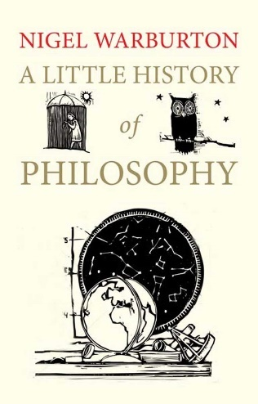
Welcome to A-Level Philosophy. In this course you will have the opportunity to study four topic areas within Philosophy; epistemology, moral philosophy metaphysics of God and the mind.
- An introduction to Philosophy
Nigel Warburton is an excellent lecturer in Philosophy who is superb at explaining in Philosophy in ways that is both engaging and easy to access. Listen to this media clip. It is from Warburton’s books, ‘A little history of Philosophy’. By listening to this you will understand how and why Philosophy began. This knowledge underpins all that we study:
https://www.youtube.com/watch?v=gQMj-FSOAMA
Make notes on what Warburton says. Focus on key philosophers and what the ideas were that he/she develops.
- Understanding the key terms
In the first unit we will be studying the importance of knowledge. Create a dictionary list for the following key concepts:
- Truth
- Belief
- Justification
- Knowledge
- Necessary and sufficient conditions
- Philosophical Problems
Here are some classic philosophical problems. Write down what you think the answer is and justify why you think that.

A. Hobbes' The Ship of Theseus
There is a very well-used boat. During the life of a ship, parts break down and are replaced. The mast, for instance, is lost in a storm and so they get a new one, some of the wood rots and is replaced with fresh timber, and the bolts and nails holding it together rust away and replaced with fresh nails. Eventually, none of the original materials that made up the ship are there. Yet, the boat still sails, same as ever. Is this the same boat or a different boat now?

B. Nozick's Experience Machine
A mad scientist invents a machine that would allow you to live in a personalized simulation, similar to a video game or the Matrix. The scientist can guarantee that you will be happy in this machine as it caters to your every whim and fantasy, and while you are in the machine, you won't even know it is a simulation. All that said, every person and thing you encounter within the machine is simply a programmed simulation and nothing and no one you encounter will be real. The catch is this... if you choose to live in the simulation, you can never go back to the real world. What would you do? Spend the rest of your life where you are happy in a fantasy world? Or choose to live your life in the real world? Why?

- Reading the words of a philosopher.

Read through what Descartes is saying (text on the next page). Essentially, he believes are sense are being controlled by an evil demon and we are actually in a dream world. Highlight any reasons he gives as to why he doubts the senses to be giving him an accurate understanding of the world. Also highlight the reasons why God cannot be the one deceiving him. This will help you understand why some philosophers say we cannot trust the knowledge we gain from the world around us. It is an extreme view, however it is interesting nonetheless and one which provokes debate.

